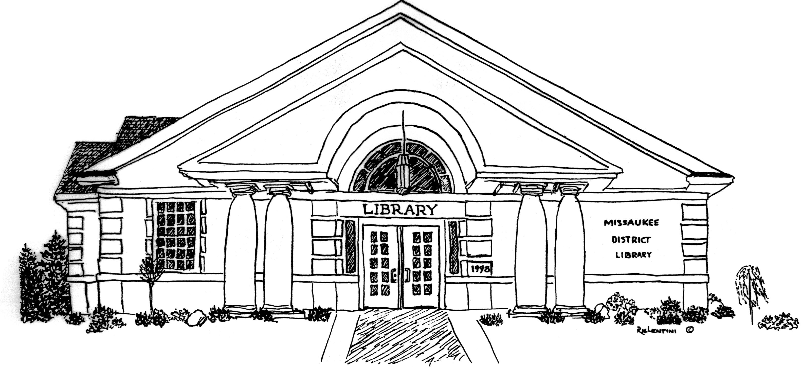
Ardis Missaukee District Library
210 South Canal Street, PO Box 340
Lake City, Michigan 49651
phone: 231-839-2166

COVID-19 PREPAREDNESS AND RESPONSE PLAN
Prepared: May 29, 2020

Compliments of the
Cadillac Area Community Foundation

COVID-19 PREPAREDNESS AND RESPONSE PLAN

Missaukee District Library takes the health and safety of our employees seriously. We are all living through the spread of COVID-19 and the need for certain employees to continue in-person work. We want you to know that we are committed to reducing the risk of exposure to COVID-19, and we are ready to provide a healthy and safe workplace for our employees, patrons, and the general public.

Our plan is based on information and guidance from the Centers for Disease Control (CDC) and the Occupational Health and Safety Administration (OSHA) at the time of its development. Because the COVID-19 situation is frequently changing, the need for modifications may occur based on further guidance provided by the CDC, OSHA, and other public officials at the state or local levels. Missaukee District Library is focused on three lines of defense:
- Limiting the number of people together at the same time in the same place,
- Sanitizing all areas and
- Recommending appropriate personal protection equipment including masks and sneeze guards.

The spread of COVID-19 in the workplace can come from several sources:
- Co-workers
- Patrons
- The General Public

Our employees fall into the following category as defined by OSHA:
- Medium exposure risk (the work performed requires frequent and/or close contact with people who may be infected with COVID-19, but who are not known COVID-19 patients, or contact with the general public in areas where there is ongoing community transmission).

COVID-19 WORKPLACE COORDINATOR
Missaukee District Library has designated the following staff as its COVID-19 Workplace Coordinator: Laura Marion, Library Director, email director@missaukeelibrary.org, phone (231) 839-2166. Because of the nature of COVID-19, the coordinator has “on the fly decision making” in order to make changes as needed as situations change without the need of an additional library board meeting.
The Coordinator responsibilities include:
- staying up to date on federal, state and local guidance
- incorporating those recommendations into our workplace
- training on control practices, proper use of personal protective equipment, the steps employees must take to notify our library of any COVID-19 symptoms or suspected cases.
- reviewing HR policies and practices to ensure they are consistent with this Plan and existing local, state and federal requirements

RESPONSIBILITIES OF MISSAUKEE DISTRICT LIBRARY DIRECTOR:
The library director must be familiar with this Plan and be ready to answer questions from employees. Additionally, Missaukee District Library expects that the director will set a good example by following this Plan. This includes practicing good personal hygiene and job site safety practices to prevent the spread of the virus. Managers and supervisors must encourage this same behavior from all employees.

Missaukee District Library will keep all symptoms questionnaires for employees entering the library.

Missaukee District Library will:
- Keep everyone on the library premises at least six feet from one another to the maximum extent possible, through the use of ground markings, signs, and physical barriers.
- Provide non-medical grade face coverings to their employees and sneeze guards at work stations.
- Recommend face coverings to be worn when employees cannot consistently maintain six feet of separation from other individuals in the library or station themselves behind a plexiglass guard.
- Increase facility cleaning and disinfection to limit exposure to COVID-19, especially on high-touch surfaces, paying special attention to countertops, tables, and shared equipment.
- Clean and disinfect the facility in the event of a positive COVID-19 case in the workplace.
- Make cleaning supplies available to employees upon entry and provide time for employees to wash hands frequently or to use hand sanitizer.
- When an employee is identified with a confirmed case of COVID-19, within 24 hours, notify both the local public health department, and any co-workers who may have come into contact with the person.

RESPONSIBILITIES OF EMPLOYEES

We are asking each of our employees to help with our prevention efforts while at work. Missaukee District Library, understands that to minimize the impact of COVID-19 at our facility, everyone needs to play his or her part. We have instituted several best practices to minimize exposure to COVID-19 and prevent its spread in the workplace. While here at work, all employees must follow these best practices for them to be effective. Beyond these best practices, we require employees to report to their managers or supervisors immediately if they are experiencing signs or symptoms of COVID-19, as described below.

OSHA and the CDC Prevention Guidelines
OSHA and the CDC have provided the following preventive guidance for workers, regardless of exposure risk:
- Frequently wash your hands with soap and water for at least 20 seconds. When soap and running water are unavailable, use an alcohol-based hand rub with at least 60% alcohol.
- Avoid touching your eyes, nose, or mouth with unwashed hands.
- Follow appropriate respiratory etiquette, which includes coverage for coughs and sneezes.
- Avoid close contact with anyone who is sick.
- Maintain an appropriate social distance of six feet to the greatest extent possible.

Additionally, employees must familiarize themselves with the symptoms and exposure risks of COVID-19. The primary symptoms of COVID-19 include the following:
- Dry cough;
- Shortness of breath or difficulty breathing

Or at least two of these symptoms:
- Fever (either feeling feverish or a temperature of 100.4 degrees or higher);
- Chills
- Repeated shaking with chills
- Muscle pain
- Headache
- Sore throat
- New loss of taste or smell
- Diarrhea, nausea/vomiting, and runny nose.

If you develop a fever and symptoms of respiratory illness, such as an atypical cough or shortness of breath, do not report to work. You must also notify your supervisor immediately, and consult their healthcare provider. Similarly, if employees come into close contact with someone showing these symptoms, they must notify their supervisor immediately and consult their healthcare provider. We have the responsibility to work to identify and notify all employees who have close contact with individuals with COVID-19 symptoms. “Close contact” is not brief or incidental contact with a person with COVID-19 symptoms.

The CDC defines “close contact” as either:
- Being within roughly six feet of a COVID-19 infected person or a person with any symptom(s) for a “prolonged period;” ( the CDC estimates range from 10 to 30 minutes)
- Having direct contact with infectious secretions of a COVID-19 infected person or a person with any COVID-19 symptom(s) (i.e., being coughed on).

HEALTH AND SAFETY PREVENTATIVE MEASURES FOR MISSAUKEE DISTRICT LIBRARY

Missaukee District Library has put several best practices and measures in place to ensure the health and safety of identified groups of individuals. With each group of individuals, our Plan is focused on three lines of defense – limiting the number of people together at a time, sanitizing all areas, and requiring appropriate personal protection equipment.

Minimizing exposure from co-workers.
Missaukee District Library takes the following steps to minimize exposure from co-workers to COVID-19 by educating employees on protective behaviors that reduce the spread of COVID-19 and provide employees with the necessary tools for these protective behaviors.

General Education:
- Providing tissues and no-touch trash bins to minimize exposure to infectious secretions
- Encourage good hand hygiene by ensuring that adequate supplies of soap and hand sanitizer are maintained and placing hand sanitizers in multiple locations.
- Discourage handshaking and encourage the use of other non-contact methods of greeting
- When possible, avoid the use of other employees’ phones, desks, offices, other work tools and equipment, and other commonly touched surfaces.
- If the above cannot be avoided, clean and disinfect them before and after use
- ALL drinking fountains will be turned off and deemed unusable.

Social Distancing
- Encourage social distancing to the greatest extent possible while in the workplace
- Consider the use of masks and gloves
- Offering a delivery system such as curbside pick-up

Checklist for Employers when an employee tests positive for COVID-19
- Treat positive test results and “suspected but unconfirmed” cases of COVID-19 the same.
- If the source of infection is known, identify if it was at the workplace or outside.
- If the infection was contracted inside the workplace, notify workers’ compensation carrier;
  - Place the employee on workers’ compensation leave (with pay); and
  - Record the infection in the employer’s OSHA 300 log.
- Implement employee paid sick leave.
- Ask the employee if he or she grants the employer permission to disclose the fact that the employee is infected.
  - If yes:
    - Notify the employee’s manager(s) or supervisor(s) that the employee is infected with COVID-19 and is out on leave.
    - For everyone else, respond to inquiries by disclosing employee is on a leave of absence for non-disciplinary purposes.
  - If no:
    - Notify the employee’s manager(s) or supervisor(s) only that employee is on a leave of absence for non-disciplinary purposes.
  - Regardless of yes or no:
    - Disclose the identity of the employee to any required notification to OSHA or the health department.
- Notify employee’s co-workers who may have come into contact with employees at work within the past 14 days that they may have been exposed to COVID-19 and may wish to see a healthcare provider.
- DO NOT identify the infected employee by name and to the greatest extent possible, avoid making any direct or indirect references that would lead co-workers to the identity of the employee.
- For employees who had close contact with employees in the past 14 days, send them home for a 14-day self-quarantine.
- Notify known customers, vendors, or third parties with whom the employee may have come into contact with while at work within the past 14 days that they may have been exposed to COVID-19 and may wish to see a healthcare provider. DO NOT identify the infected employee by name.
- To the extent reasonably possible, avoid making any direct or indirect references that would lead the person to guess the identity of the employee.
- Arrange for a professional cleaning of the employee’s workspace, surrounding area, and areas visited.

Restrict employees from the workplace if they display symptoms of COVID-19
- For employees who are completing in-person work, a questionnaire must be completed before entry into the facility.
- Any employee with COVID-19 symptoms will be immediately sent home.
- Guidance from the employee’s health care provider on their return to work date will be required.

Actively encourage sick employees to stay home:
- Missaukee District Library will follow state and federal guidelines for return to work guidance.
- Guidance from the employee’s health care provider will also be considered

Minimizing exposure from those outside of our workforce including patrons and the general public.

- Making hand sanitizer available to all BEFORE entering the library
- Social distancing practices to be observed:
- 6-foot distances are marked in areas where patrons might gather/wait
- Marking areas behind plexiglass shields where patrons may communicate with clerks (in front of 2 clerk stations, by the cash register, and on the children’s check-out counter)
- Limit the number of customers allowed into the workplace
- Computer stations positioned at least 6 feet apart with sanitizing wipes at each station

- Information is posted throughout the worksite about ways to reduce the spread of COVID-19
- Missaukee District Library will provide appropriate disinfectants so that individuals can clean work areas before and after use.

This Plan is based on information and guidance from the CDC and OSHA at the time of its development. The safety of our employees and visitors remains the top priority at Missaukee District Library. We recognize that all individuals are responsible for preventing the spread of COVID-19 and reduce the potential risk of exposure to our workforce and visitors. As the COVID-19 outbreak continues to evolve and spread, Missaukee District Library is monitoring the situation closely and will update our guidance based on the most current recommendations from the CDC, World Health Organization (WHO), OSHA, and any other public entities.

