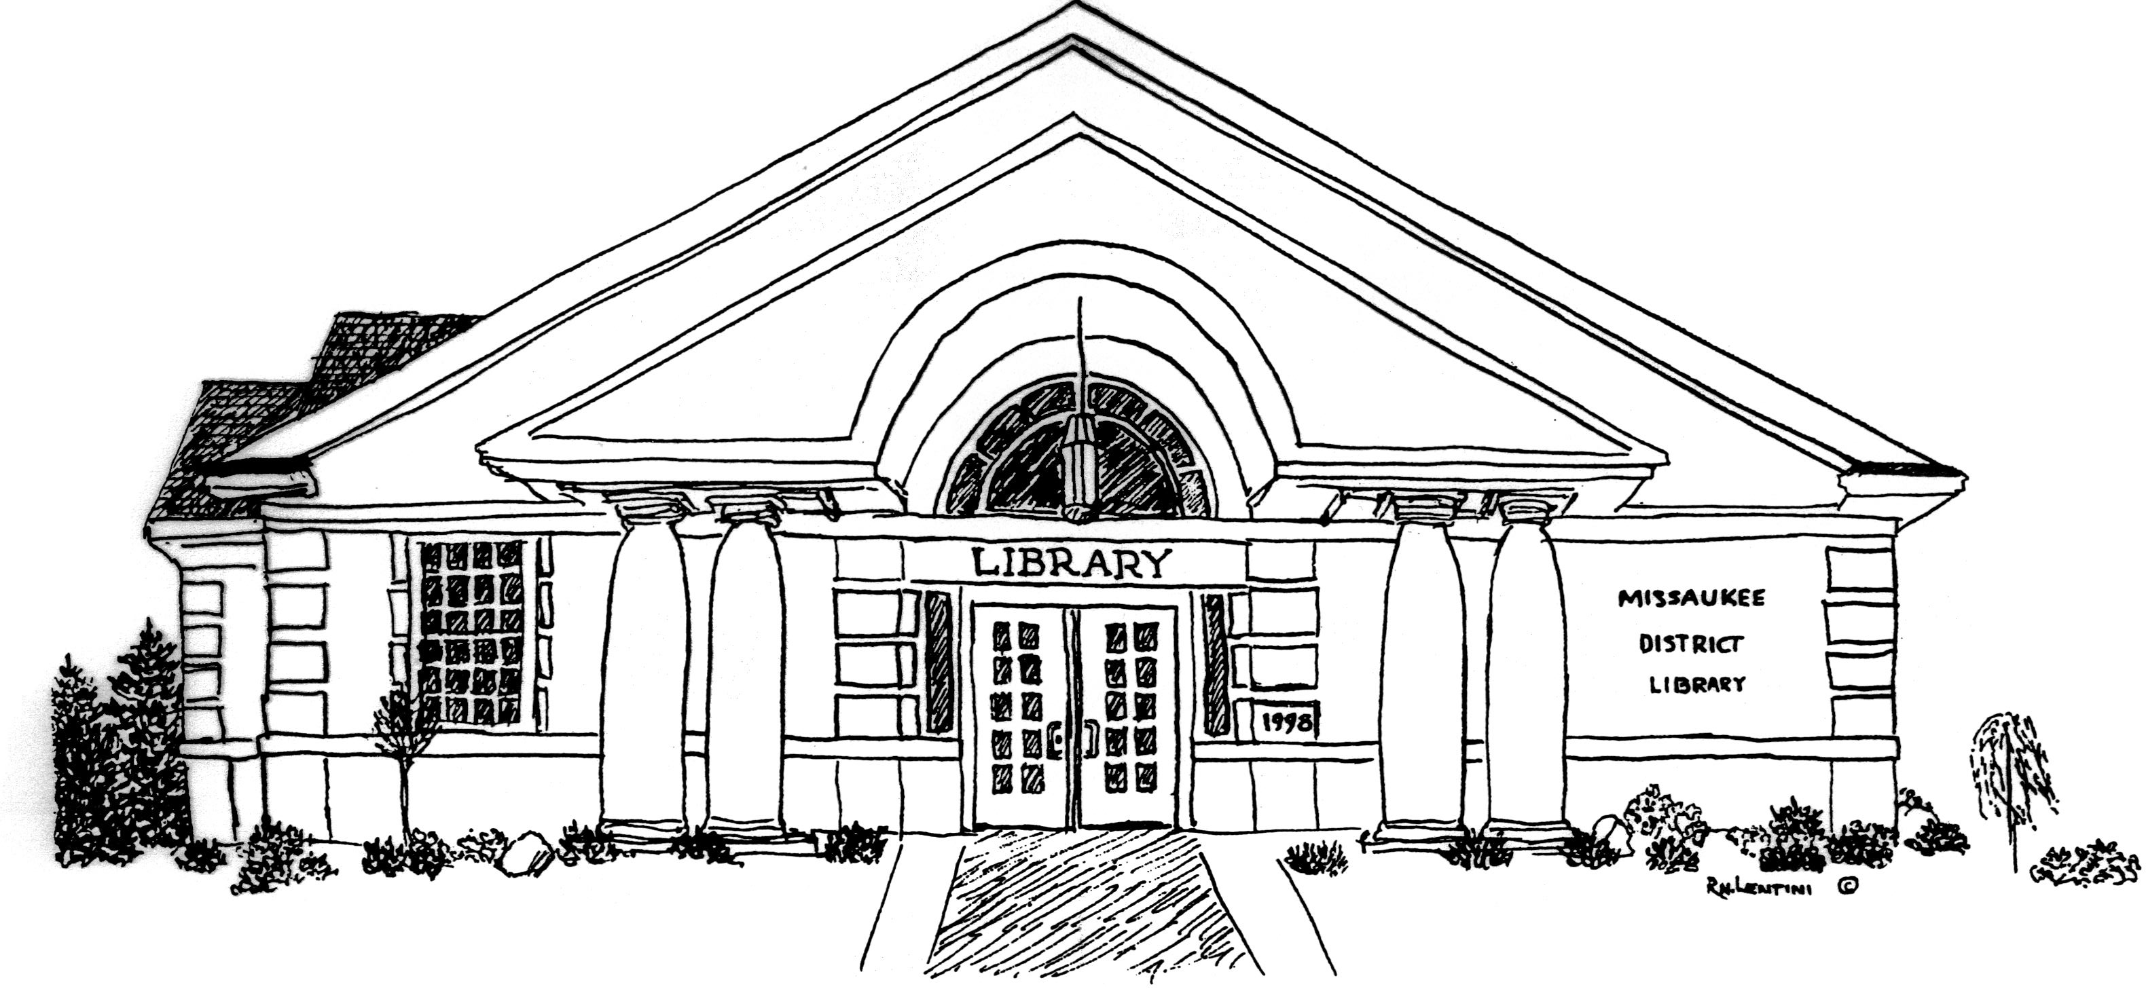
Ardis Missaukee District Library
210 South Canal Street, PO Box 340
Lake City, Michigan 49651
phone: 231-839-2166

Presented at May Library Board Meeting on March 18, 2020

Phase Back to Work Plan

Phase 1: Limited staff return to update collection, clean, prepare building for social distancing guidelines including signage and gear, and collection of personal protective equipment.
(Beginning May 19, 2020)

Phase 2: Partial reopening, limited number of patrons/services/spaces, curbside service, and cleaning throughout the day following guidelines of health department. Collection quarantine with paperback books needing 24 hours and milar-covered books needing 24 hours after sanitation.
(Beginning June 8, 2020)

Phase 3: Expanded reopening, expanded number of patrons/services/spaces, appropriate safeguards continued.
(As appropriate)

Phase 4: Full reopening, appropriate safeguards continued.
(As appropriate)
- Wash hands regularly for at least 20 seconds with soap and water,
- Limit contact with others by remaining six feet apart,
- Clean and disinfect frequently touched surfaces and tools routinely,
- Stay home if you or someone in your household is sick,
- Avoid touching your eyes, nose or mouth, and
- Practice self-screenings to check for any symptoms.

